RED MOON STUDIO

**Final Project Documentation**

**C.I.T. (Evening Batch)**

**Navttc Aptech Shahrah-e-Faisal**

**Mentor : Sir Raza Hussain**

**Developed By:**

**Ahmed Raza**

RED MOON STUDIO

SUMMARY

RED MOON STUDIO IS THE MANAGEMENT SYSTEM APP IN WHICH ADMIN CAN ADD PHOTOGRAPHERS & BOOK EVENTS.

FEATURES

1. Admin can login to use app.
2. Admin can add photographer with his complete details.
3. Admin can add event details for photography booking details are as below:
   1. Select photographer which can be add in photographer form before.
   2. Booker Name.
   3. Event venue.
   4. Camera details either only 1 DSLR & drone if require.
   5. Event date & time.
   6. Photography charges.
   7. Google drive link if upload pics on drive.
4. View All Photographers with complete details.
5. View Upcoming Events with details.
6. View Post (History) Events.
7. View Post/History events report.

APPLICATION VIEW

*Application**Startup***:**



*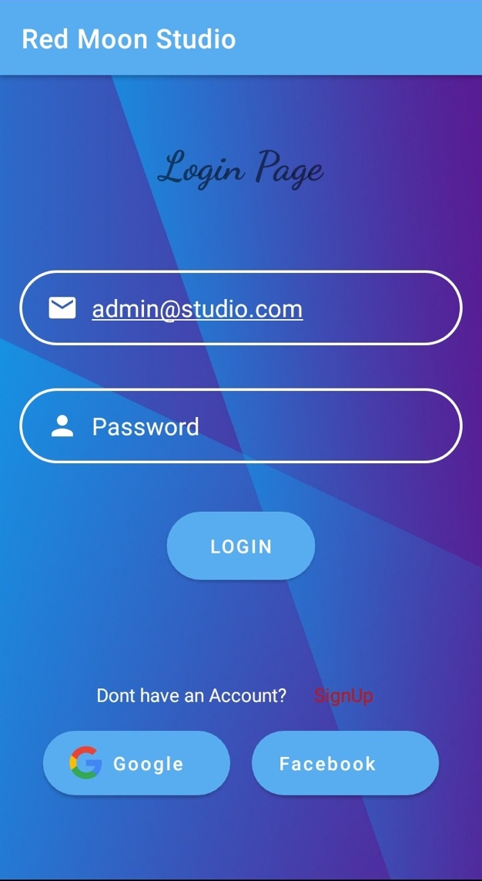Admin**Login**Panel***:**

*Home View:*

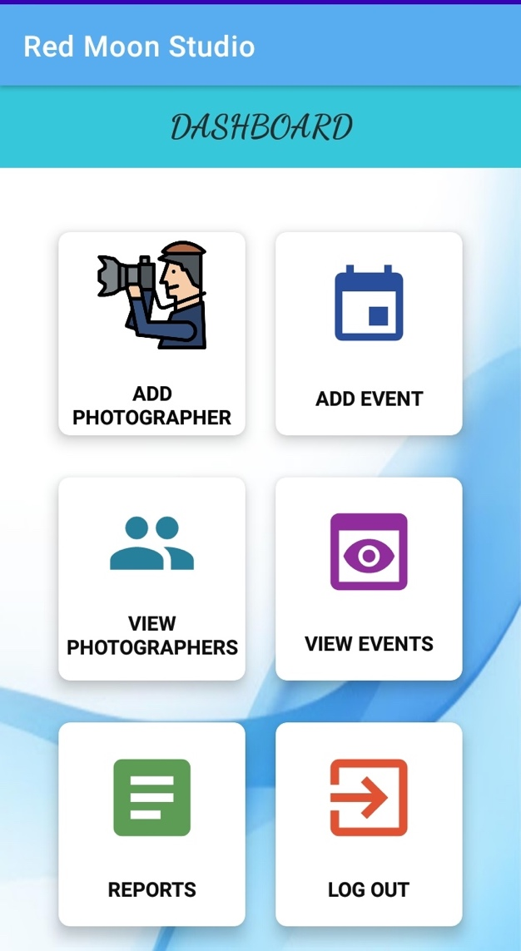

*Add Photographer:*

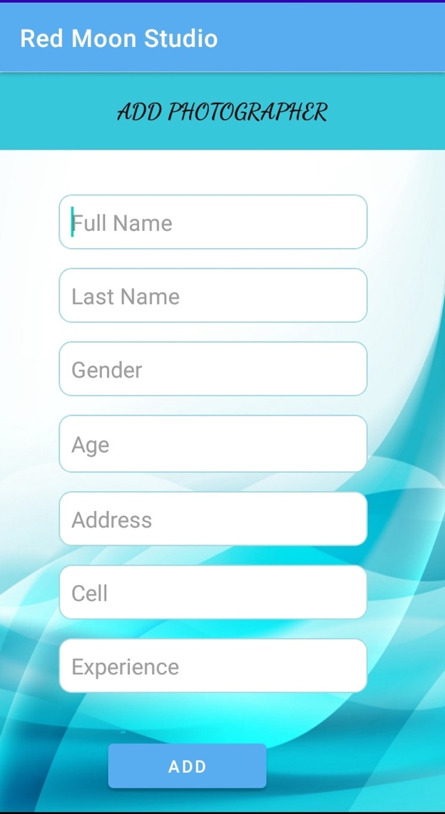

*Add Event:*

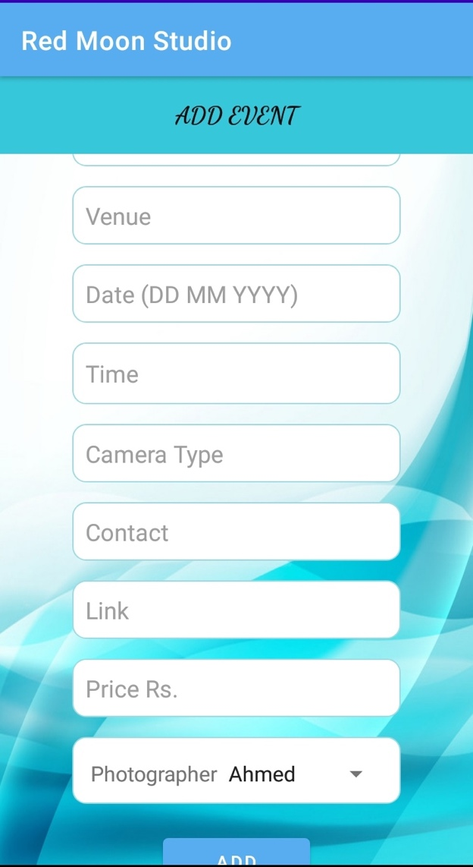

*View Photographers:*

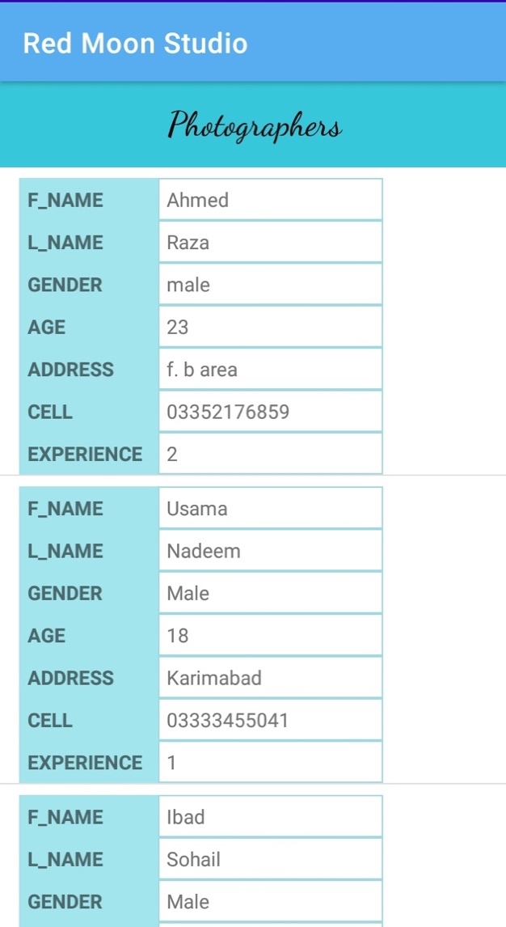

*View Upcoming & Post Events: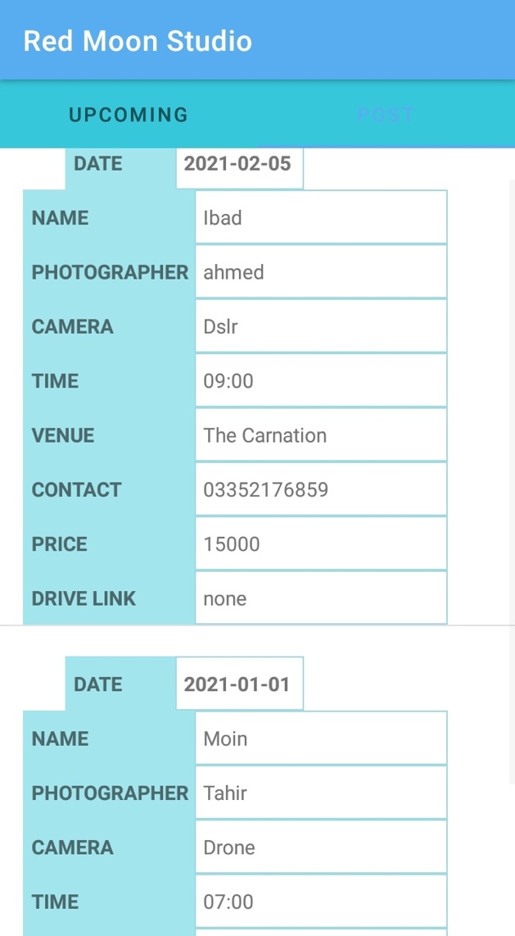*

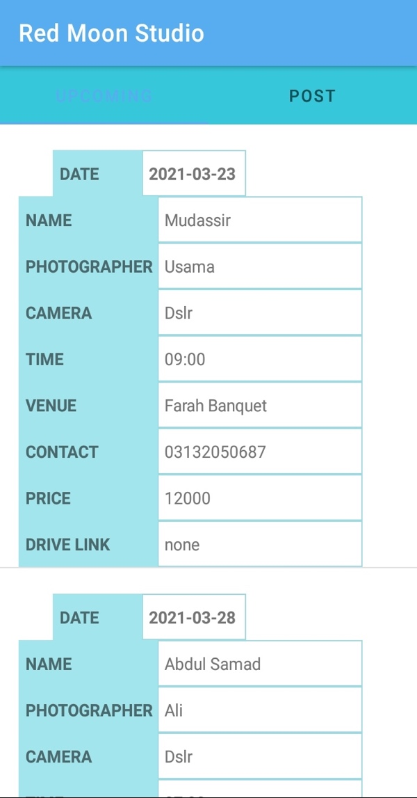

*Reports:*

